Position Opening:
Master Thesis in Stem Cell Biology and Oxytocin Neuroscience
We are seeking a motivated and skilled Master student to join our laboratory for a thesis project focusing on human induced pluripotent stem cell (hiPSC) research and neuronal differentiation. The project is embedded in a translational neuroscience framework, exploring the physiology of human oxytocin system.
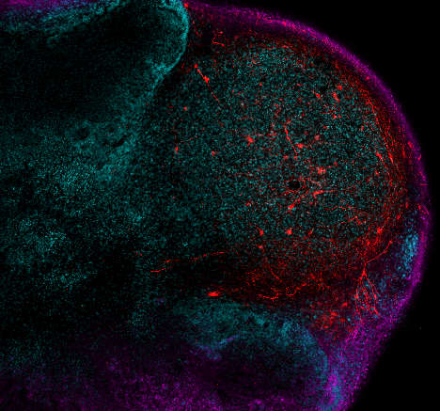
The Master student will be responsible for routine culture and maintenance of hiPSCs and neuronal progenitors, as well as their differentiation into neuronal lineages. The project will involve advanced cell handling techniques, including viral transfection, cryopreservation, and spheroid culture. In addition, the student will perform immunostainings, RNAscope experiments, and cryostat sectioning of brain tissue and spheroids, as well as use advanced imaging platforms such as confocal microscopy. Alongside the laboratory work, the student will contribute to literature reviews and actively engage in the interpretation of experimental results.
(cortico-hypothalamic assembloids with neuronal oxytocin staining in red)

Please note: this position requires applicants with hands-on experience in hiPSC maintenance and neuronal cell culture, who can work independently after initial training.
In return, we offer integration into a dynamic neuroscience research group with international collaborations, and the opportunity to carry out a thesis project connected to cutting-edge questions in stem cell biology and neuropeptidergic signaling.
Interested candidates are invited to send their CV, transcript of records, and a brief statement of motivation to valery.grinevich@zi-mannheim.de.

PhD candidate responsible for the project:
Ana Zovko (email: ana.zovko@zi-mannheim.de)
Project supervisors:
Prof. Dr. Valery Grinevich, Department of Neuropeptide Research in Psychiatry, ZI Mannheim (email: valery.grinevich@zi-mannheim.de
Prof. Dr. Philipp Koch, Hector Institute for Translational Brain Research (email: philipp.koch@zi-mannheim.de)

